**GCP Overview**

**General information:**

Google Compute Engine is a cloud-based infrastructure as a service (IaaS) offering from Google Cloud Platform (GCP). It allows users to run virtual machines (VMs) on Google's global infrastructure.

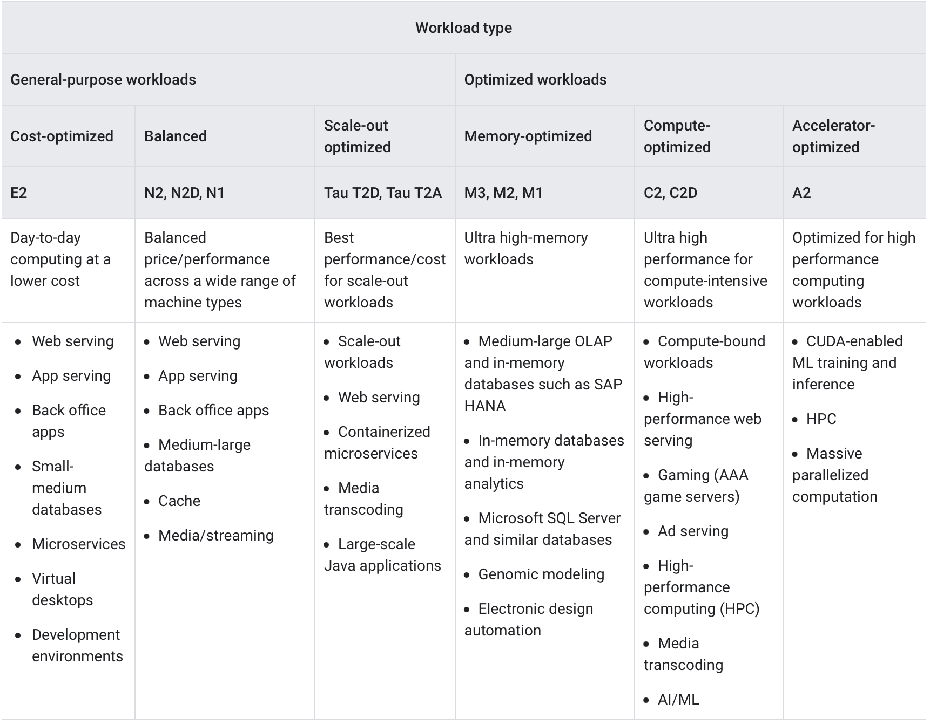Instance families

Detailed overview instance families: <https://cloud.google.com/compute/docs/machine-resource>

**Price models:**

* **Pay-as-you-go**
  + Charged for a minimum of one minute, then in 1 second increments
* **Spot VMs**
  + Automatic discount between 60% and 91%
  + Spot VMs provide significant discounts for VMs. Additionally, you receive discounts for [GPUs](https://cloud.google.com/compute/gpus-pricing), [local SSDs](https://cloud.google.com/compute/disks-image-pricing#localssdpricing), and [external IP addresses](https://cloud.google.com/vpc/network-pricing#ipaddress) that are attached to Spot VMs.
  + If a preempted VM was stopped, you are not charged for the VM hours while it remains in a TERMINATED state. You can access and recover data from any persistent disks that are attached to the VM, but those disks still incur storage charges until you delete them.
  + Spot prices, the prices for Spot VMs, change over time, up to once every 30 days
  + Spot VMs cant apply CUDs or SUDs
* **Commited Use Discounts (CUDs)**
  + up to a 70% discount for memory-optimized machine types and up to a 57% discount for all other machine types.
  + When you purchase a commitment, you commit either to a minimum amount of resource usage or to a minimum spend amount for a specified term of one or three years.
  + **Resource-based committed use discounts:** You receive these CUDs when you purchase a resource-based commitment and commit to use a minimum level of Compute Engine resources in a particular region.
    - vCPU for 1 year gets discount of 37%
    - 3 year commitment gets 70% percent discount on memory optimized machined and 57% on all other machine types
  + **Compute Engine flexible committed use discounts:** You avail flexible CUDs when you purchase a spend-based (or flexible) commitment for Compute Engine and commit to a minimum amount of hourly spend.
    - A 28% discount over your committed hourly spend amount for a 1-year commitment
    - A 46% discount over your committed hourly spend amount for a 3-year commitment
* **Sustained Use Discounts**
  + Compute Engine offers automatic discounts for sustained use of vCPUs and memory that are not receiving any other discounts.
  + Whenever you use an applicable vCPU or an applicable GB of memory for more than 25% of a month, Compute Engine automatically gives you a sustained use discount for every incremental hour that you continue to use that resource.
  + The discount increases with usage and you can get up to a 30% net discount off of the vCPU and memory cost for instances that run the entire month.

**Links:**

Compute Engine Prices (On demand, Spot, commitment): <https://cloud.google.com/compute/all-pricing>

SUD Prices: <https://cloud.google.com/compute/docs/sustained-use-discounts>